AI Powered Smart Health Assistant
Design Document

Version 1.0



Group Id: F25PROJECT664B0 (BC220422631)

Supervisor Name: Shakeel Saeed

Revision History
Date (dd/mm/yyyy) | Version | Description | Author
01/01/2026 | 1.0 | This project develops an AI-based health analysis system that helps users understand their symptoms and receive simple, reliable triage advice. By processing user inputs and predicting possible conditions, the system guides users on whether to use self-care, visit a doctor, or seek urgent help. The goal is to provide quick, accessible, and personalized health insights to support better decision-making. | BC220422631

Table of Contents

- Introduction of Design Document
- Entity Relationship Diagram (ERD)
- Sequence Diagrams
- Architecture Design Diagram
- Class Diagram
- Database Design
- Interface Design
- Test Cases

- Introduction of Design Document

1. Introduction of Design Document
This design document presents the detailed system design of the AI-Based Healthcare Chatbot System. The primary purpose of this document is to transform the approved Software Requirements Specification (SRS) into a well-structured technical design that guides system implementation, testing, and future maintenance.
The design document acts as a blueprint for developers and stakeholders by clearly defining the system architecture, data organization, component interactions, and user interface flow. It helps minimize ambiguity during development, improves implementation efficiency, and ensures alignment with the approved system requirements. Moreover, this document supports system scalability, maintainability, and effective collaboration throughout the software development lifecycle.
This document includes the following design artifacts:
- Entity Relationship Diagram (ERD):
Represents the conceptual data model of the system by identifying core entities, their attributes, and relationships, ensuring accurate data organization and integrity.
- Database Design Diagram:
Provides a logical view of how system data is structured and stored, mapping entities into database tables to support efficient data retrieval and persistence.
- Sequence Diagrams:
Illustrate the dynamic behavior of the system by showing the interaction flow between system components during key processes such as user authentication, symptom analysis, and AI prediction.
- Tiered Architecture Diagram:
Defines the overall system architecture by separating responsibilities into presentation, application logic, AI services, and data layers to ensure modularity and scalability.
- Class Diagram:
Describes the structural design of the system by identifying classes, their attributes, methods, and relationships, aligned with the system’s object-oriented design.
- User Interface Design:
Presents the visual flow of the system, demonstrating how users interact with the chatbot, view predictions, and understand AI-generated explanations through intuitive interfaces.
- Test Cases:
Outline the validation scenarios used to verify that system components function correctly and meet the specified design expectations.
Each design artifact is developed in alignment with the approved requirements to provide a complete, consistent, and implementation-ready view of the proposed system.

- Entity Relationship Diagram (ERD)
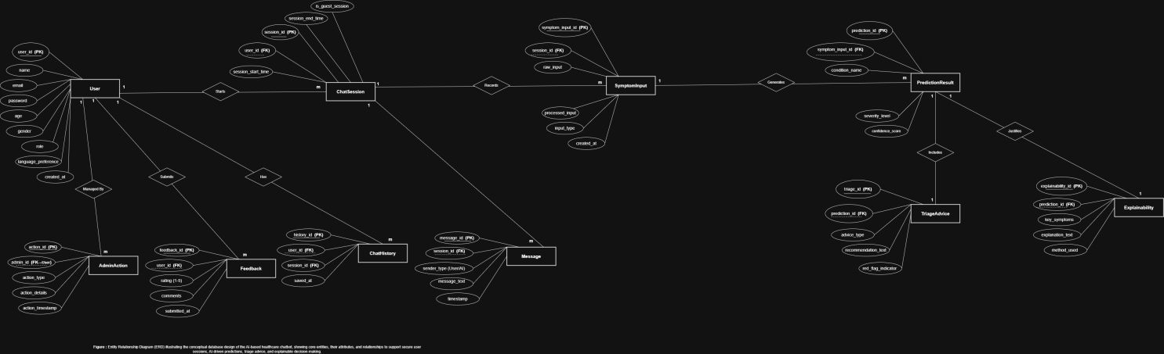
- Sequence Diagrams
Sequence Diagram#01

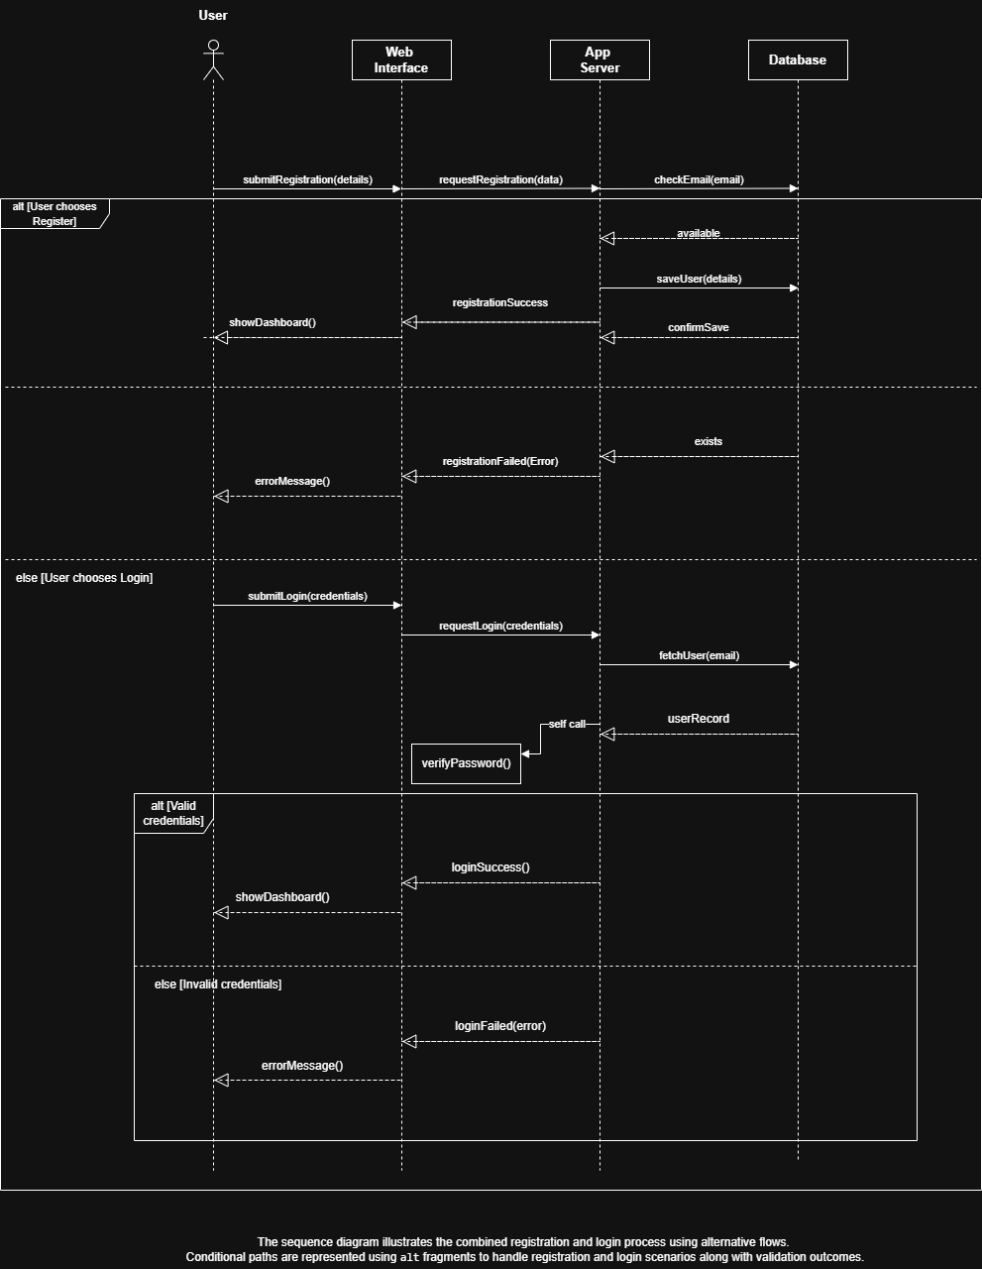
Sequence Diagram#02

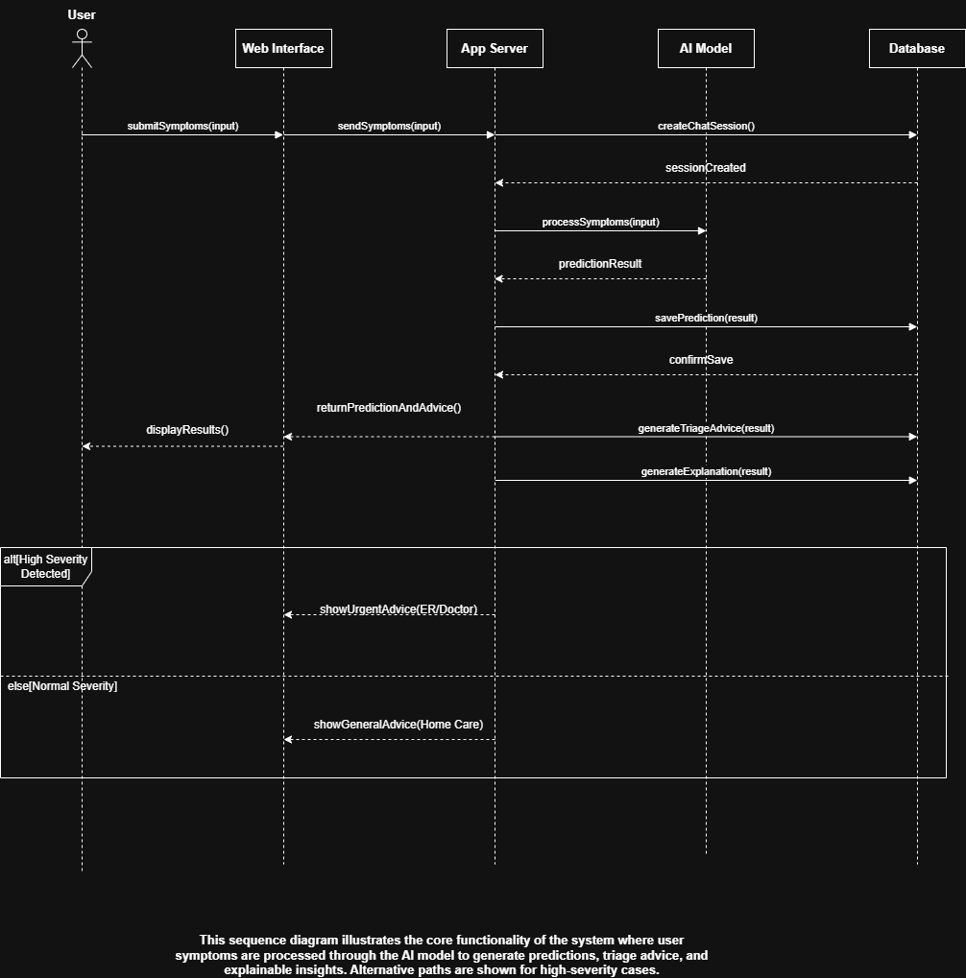
- Architecture Design Diagram
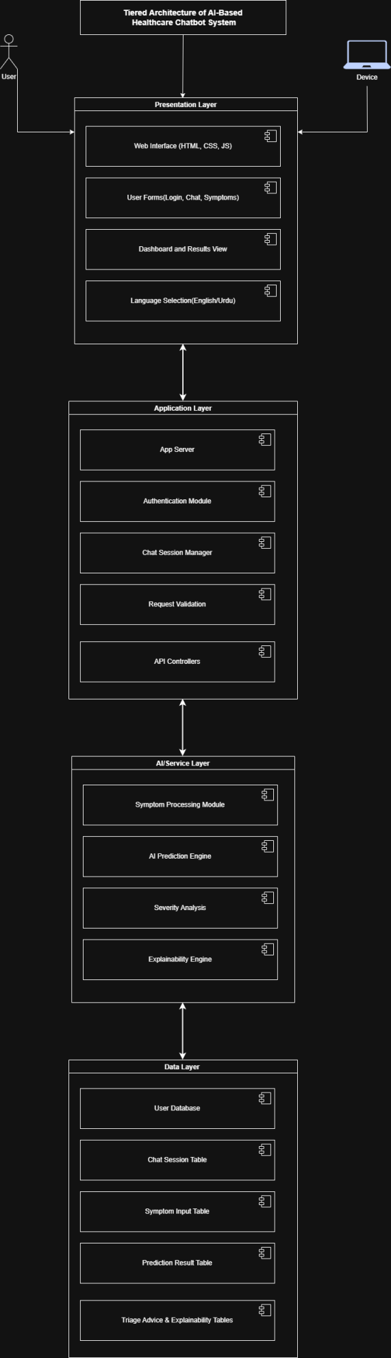
- Class Diagram

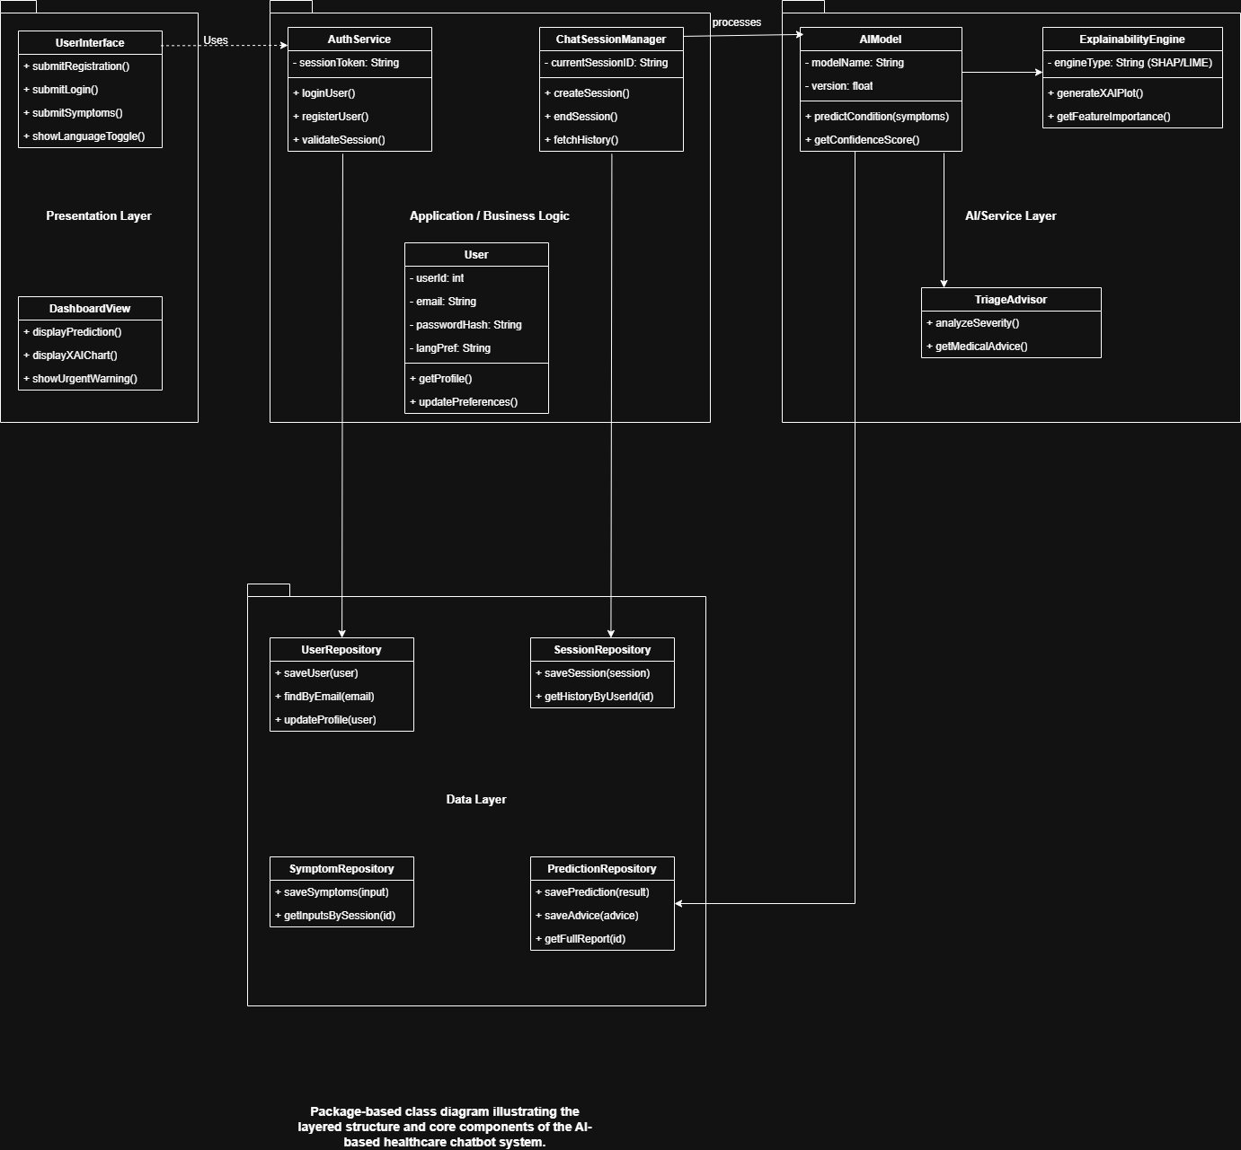

- Database Design

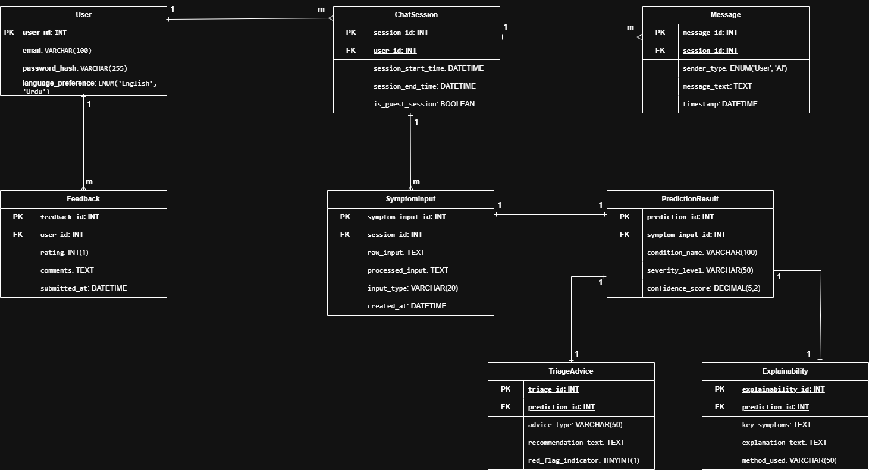
- Interface Design
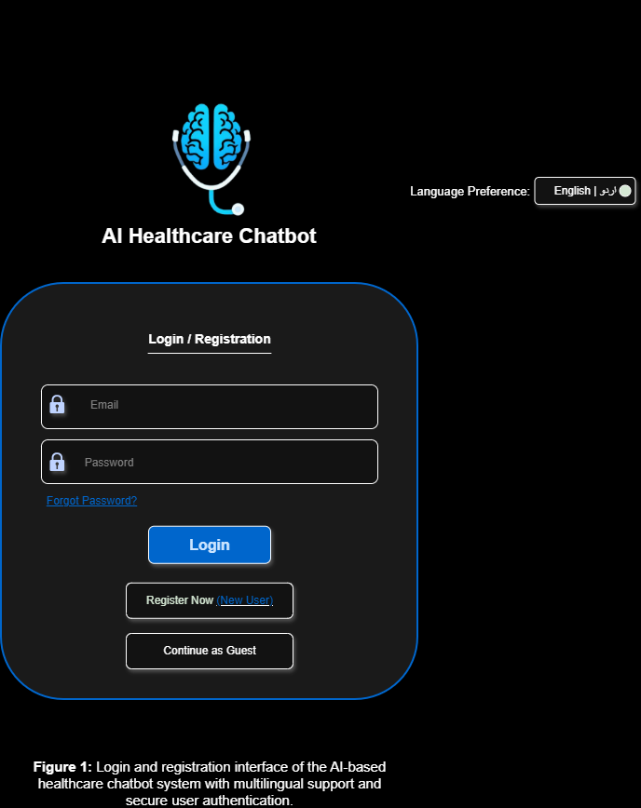

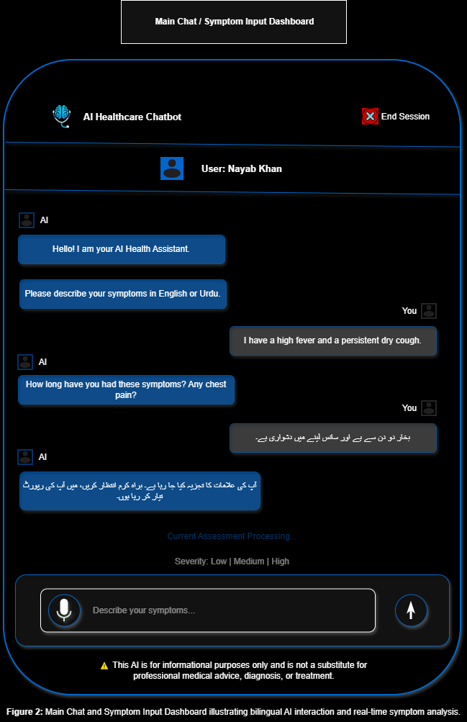
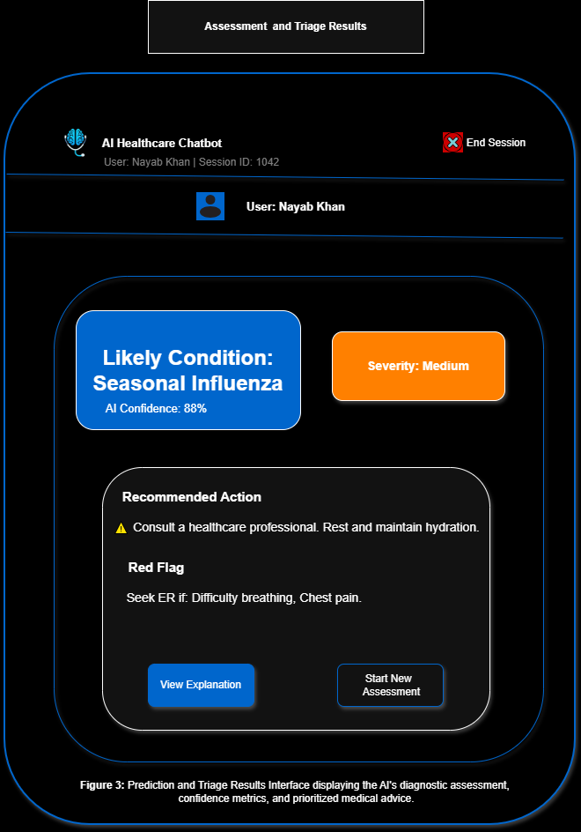
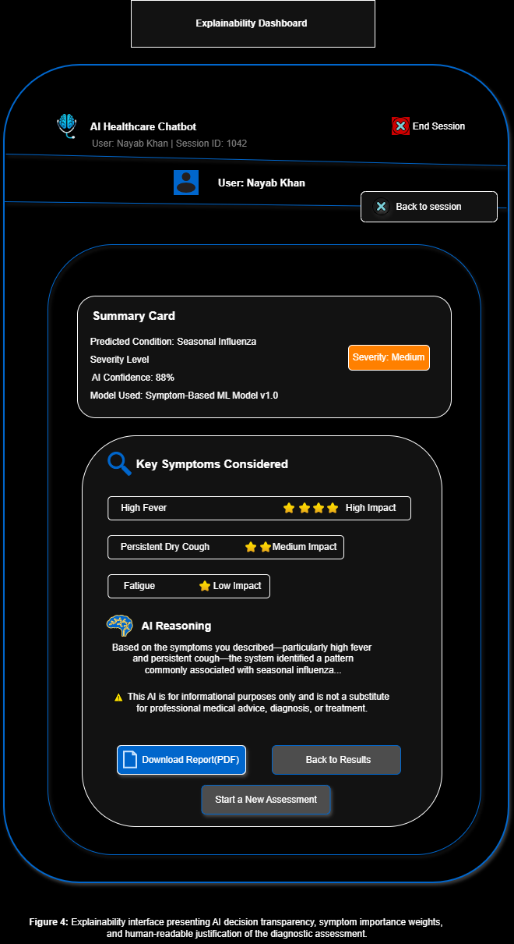

- Test Cases

Test Case 1: User Login with Valid Credentials
Field | Description
Test Case ID | TC-01
Test Case Title | User Login with Valid Credentials
Precondition | User is registered in the system
Test Steps | 1. Enter valid email and password2. Click Login
Expected Result | User is authenticated and redirected to Chat Dashboard
Actual Result | As expected (Design Phase)
Status | Pass

Test Case 2: User Login with Invalid Credentials
Field | Description
Test Case ID | TC-02
Test Case Title | User Login with Invalid Credentials
Precondition | User exists
Test Steps | 1. Enter incorrect email/password2. Click Login
Expected Result | Error message displayed
Actual Result | As expected (Design Phase)
Status | Pass

Test Case 3: New User Registration
Field | Description
Test Case ID | TC-03
Test Case Title | New User Registration
Precondition | User not registered
Test Steps | 1. Click Register Now2. Enter valid details3. Submit form
Expected Result | Account created successfully
Actual Result | As expected (Design Phase)
Status | Pass

Test Case 4: Continue as Guest
Field | Description
Test Case ID | TC-04
Test Case Title | Guest User Access
Precondition | None
Test Steps | 1. Click Continue as Guest
Expected Result | Guest session created
Actual Result | As expected (Design Phase)
Status | Pass

Test Case 5: Symptom Input (Text)
Field | Description
Test Case ID | TC-05
Test Case Title | Submit Symptoms via Text
Precondition | Active chat session
Test Steps | 1. Type symptoms2. Click Send
Expected Result | Symptoms processed by AI
Actual Result | As expected (Design Phase)
Status | Pass

Test Case 6: Bilingual Input (Urdu)
Field | Description
Test Case ID | TC-06
Test Case Title | Urdu Language Symptom Input
Precondition | Language set to Urdu
Test Steps | 1. Enter symptoms in Urdu2. Submit
Expected Result | AI processes Urdu input correctly
Actual Result | As expected (Design Phase)
Status | Pass

Test Case 7: AI Condition Prediction
Field | Description
Test Case ID | TC-07
Test Case Title | Disease Prediction
Precondition | Symptoms submitted
Test Steps | 1. Submit symptoms
Expected Result | Likely condition displayed
Actual Result | As expected (Design Phase)
Status | Pass

Test Case 8: Severity Level Detection
Field | Description
Test Case ID | TC-08
Test Case Title | Severity Classification
Precondition | AI prediction completed
Test Steps | 1. View results screen
Expected Result | Severity shown as Low/Medium/High
Actual Result | As expected (Design Phase)
Status | Pass

Test Case 9: Triage Recommendation
Field | Description
Test Case ID | TC-09
Test Case Title | Medical Advice Generation
Precondition | Prediction available
Test Steps | 1. View Recommended Action
Expected Result | Appropriate medical advice displayed
Actual Result | As expected (Design Phase)
Status | Pass

Test Case 10: Red Flag Detection
Field | Description
Test Case ID | TC-10
Test Case Title | Emergency Warning Display
Precondition | High severity detected
Test Steps | 1. Submit critical symptoms
Expected Result | ER warning shown
Actual Result | As expected (Design Phase)
Status | Pass

Test Case 11: Explainability View
Field | Description
Test Case ID | TC-11
Test Case Title | AI Explanation Display
Precondition | Prediction completed
Test Steps | 1. Click View Explanation
Expected Result | Key symptoms & reasoning shown
Actual Result | As expected (Design Phase)
Status | Pass

Test Case 12: Download Report
Field | Description
Test Case ID | TC-12
Test Case Title | Download AI Assessment Report
Precondition | Explainability screen open
Test Steps | 1. Click Download PDF
Expected Result | Report downloaded successfully
Actual Result | As expected (Design Phase)
Status | Pass

Test Case 13: Start New Assessment
Field | Description
Test Case ID | TC-13
Test Case Title | New Chat Session
Precondition | Previous session active
Test Steps | 1. Click Start New Assessment
Expected Result | New session created
Actual Result | As expected (Design Phase)
Status | Pass

Test Case 14: End Session
Field | Description
Test Case ID | TC-14
Test Case Title | End User Session
Precondition | Active session
Test Steps | 1. Click End Session
Expected Result | Session terminated safely
Actual Result | As expected (Design Phase)
Status | Pass

